**1. Create onlineproductshopping Maven Project**

Let's create a onlineproductshoppingmaven project by executing the below command:

* mvn archetype:generate
* -DgroupId = com.product
* -DartifactId = onlineproductshopping

After the maven project builds success, maven will create a default folder structure.

**2. Project Packaging Structure**

**Src**

* **src/main/java** – This folder contains Java source code packages and classes
* **src/main/resources** – This folder contains resources, such as css ,js,templates ,property files and Spring configuration

**Test**

* **src/test/java** – This folder contains the test source code packages and classes

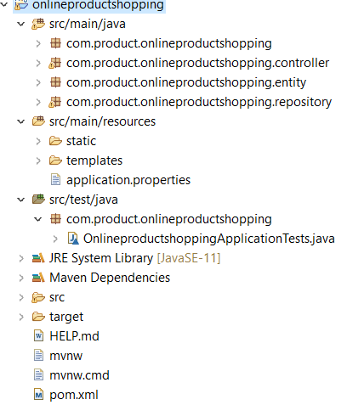

**3. Update JUnit Dependencies in pom.xml File**

Let's add below JUnit dependency to our maven project. Open the ***pom.xml*** file and add below dependency in the dependencies section:

<dependency>

<groupId>junit</groupId>

<artifactId>junit</artifactId>

<version>4.12</version>

<scope>test</scope>

</dependency>

**4. Create onlineproductshoppingApplication.java class**

Let's create a class with some logic so that we will unit test it using JUnit framework:

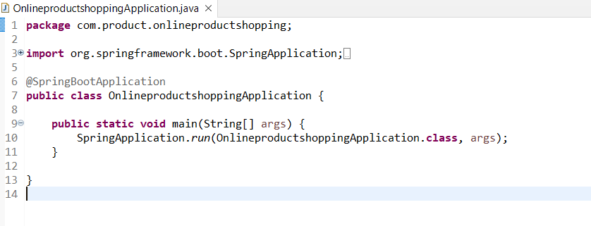s

**Create a JUnit Test for onlineproductshoppingApplication class**

Two steps required to create a simple test case.

1. Create a method and annotate a method with **@org.junit.jupiter.api.Test**

Here is the complete code:

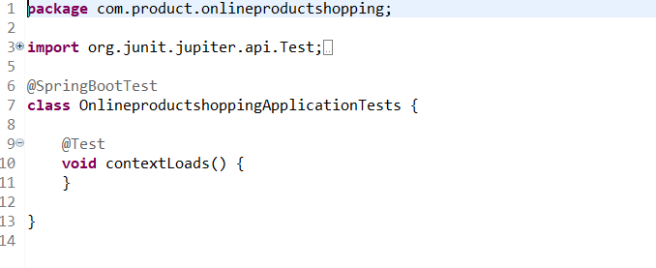

**5. Run the test**

Run the JUnit test with below maven command using command line:

mvn test

Output:

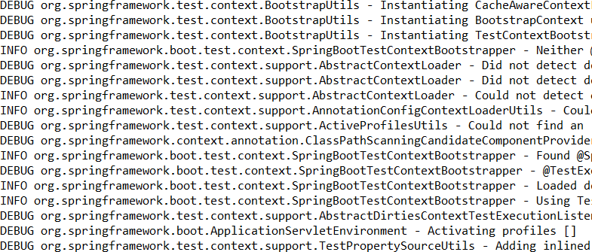

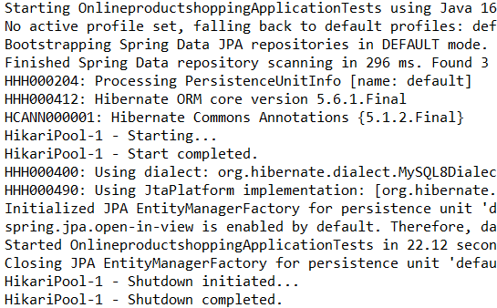

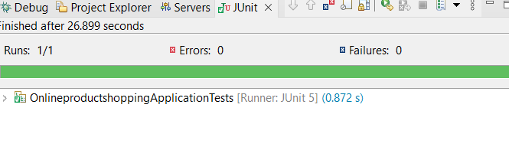

**Conclusion**

I have learned how to write a simple JUnit test case by creating a maven project.